**CUPCARBON INSTALLATION MANUAL**

**STEP 1:** Visit [www.google.com](http://www.google.com) through a browser, type for cupcarbon in the search box and click on search button

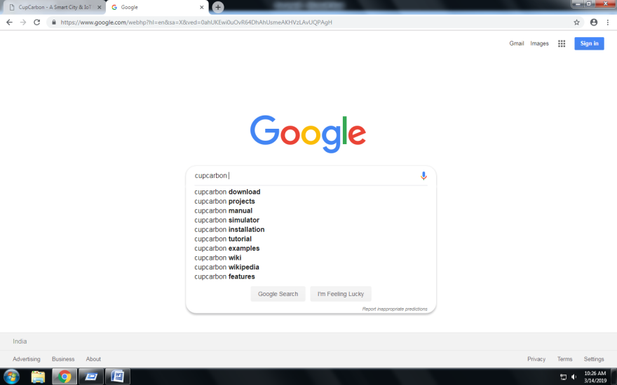

**STEP 2:** After that click on CupCarbon website [www.cupcarbon.com](http://www.cupcarbon.com).



**STEP 3:** The official webpage of CupCarbon will appear on the browser screen. Click on Download Button on the top-right section of the page.



**STEP 4:** Click on “DOWNLOAD CUPCARBON U-sONE”

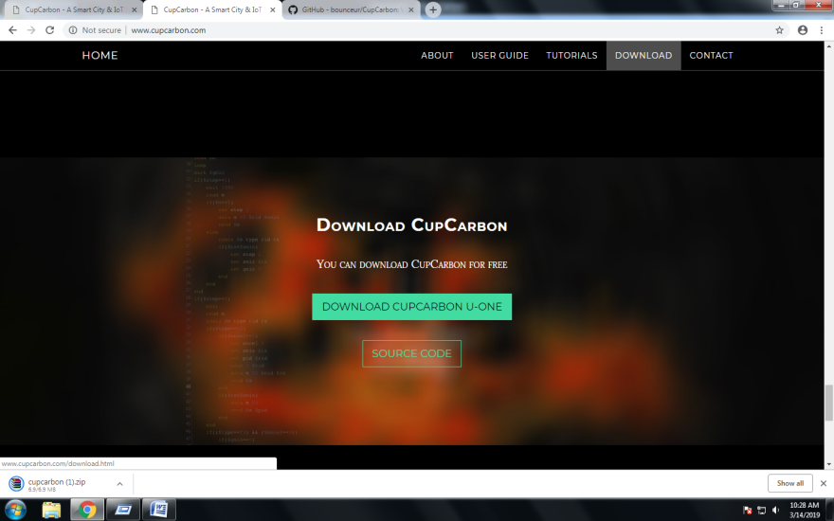

**STEP 5:** It will redirect you to the download page of cupcarbon file.



**STEP 6:** Click on “DOWNLOAD” Button. It will download a ZIP file of the software.



**STEP 7:** Browse the Downloads Folder through File Explorer. Where the File is downloaded. Then Right Click on the ZIP file and select “Extract Here”.

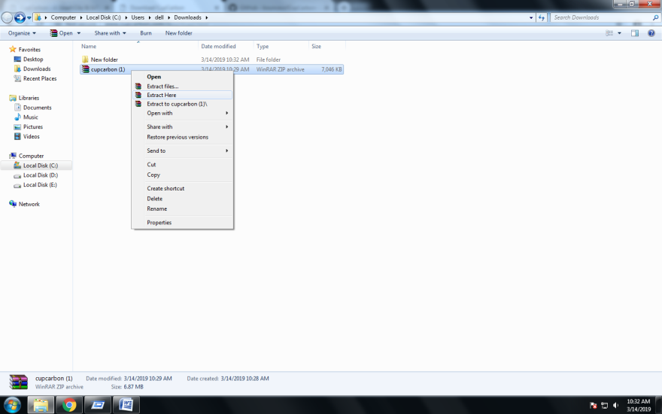

**STEP 8:** Previous step will extract all the files from the ZIP file to the current folder along with the executable JAR file of Cupcarbon. Run the JAR File “cupcarbon.jar”

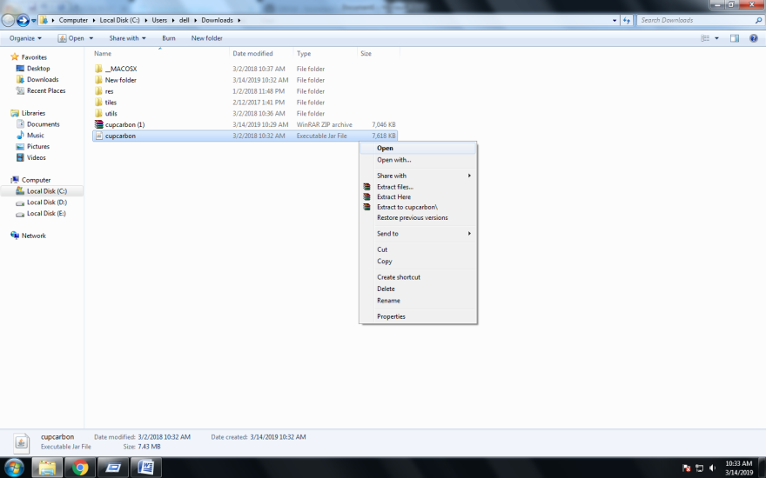

**CUPCARBON U-ONE 3.8.2 is Installed Successfully**

